SOFTWARE REQUIREMENT SPECIFICATION

**FOR**

**Commercial Bank’s International Travel Card**



**PREPARED BY:**

*Ravi Kaushik*

*Pankaj Soni*

**Date:** 03 Feb 2023

**Table of Contents:**

1. **Introduction** ……………………………………………………………………………. 02
   1. Problem Statement .…………………………………………………. 03
   2. Purpose ……………………………………………………………………. 03
   3. Scope ……………………………………………………………………….. 03
   4. Objectives/Vision ……….…………………………………………….. 03
   5. Users of the App …………………..………………………………….. 04
   6. References ……………………………………………………………….. 04
2. **User Requirements** …………………………………………………………………. 04
   1. User Profiles ………….………………………..……………………….. 04
   2. User Access ………………………………………………………………. 05
   3. User Interface ………………………………………………………….. 05
   4. User Data …………….…………………………………………………… 05
3. **Functional Requirements** ………………………..………………………….… 05
   1. Registration Page ….…………………………………………………. 05
   2. Login Page ………………...…………………………………………….. 06
   3. Dashboard Display …………………………………………….…….. 06
   4. Search Functionality ….……………………………………………… 06
   5. Personalization …………………………..………………………..….. 06
4. **Non-Functional Requirements .**…………………………………………… 06
   1. Security ……………….…………………………………………………. 06
   2. Accessibility ……………...…………………………………………….. 07
   3. Compatibility …………………..……………………………….…….. 07
   4. Performance …………….……………………………………………… 07
5. **Hardware Requirement** …………………..…………………………………… 07
   1. Server ………………….…………………………………………………. 07
   2. Storage …….……………...…………………………………………….. 07
   3. Network …….…………………..……………………………….…….. 07
6. **Software/Technical Requirements** ….…………………………………… 08
   1. Front-End ……..…….…………………………………………………. 08
   2. Programming Language ………………………………………….. 08
   3. Frameworks …….……………..……………………………….…….. 08
   4. Databases ….…………………..……………………………….…….. 08
7. **Testing Evaluation** ………………………………………..…….………………… 08
   1. Test Plan .…………….……………………………….…………………. 08
   2. User Acceptance Testing ..……………………….……………….. 09
   3. Performance Testing .……..……………………….……….…….. 09
   4. Security Testing ..……………..……………………………….…….. 09
8. **Diagram Used** ………………………….………………………………..…………… 09
9. **Conclusion** ……………………………….………………………………..…………… 11
10. **INTRODUCTION:**
    1. **Problem Statement:**

This commercial bank’s international travel card is very popular with not just its own customers, but also many other bank customers.

Business team is keen to provide various card usage analysis as dashboard to consumers that shows consumer spend and allows users to search easily.

Could your team help think and create personalized dashboard that consumer can access from any of his / her devices/computers?

**1.2 Purpose:**

The purpose of this document is to provide a detailed description of the requirements for the international travel card usage analysis dashboard. This document will serve as a guide for the development team and stakeholders to understand the requirements of the project and to ensure that the final product meets the needs of the end users.

**1.2 Scope:**

The scope of this project is to create a personalized dashboard that allows users to view their spend on the international travel card and to perform search easily. The dashboard will be accessible from any device or computer with internet access. Additionally, the project will include the development of necessary data integration, security and user authentication mechanisms.

**1.2 Objectives/Vision:**

The international travel card is a popular product among the bank's customers and many other bank customers. The business team is keen to provide various card usage analysis as a dashboard to consumers.

The dashboard will provide consumers with a convenient and user-friendly way to view their spend on the international travel card, perform search easily and also keep the track of their transaction details.

**1.3 Users of the App:**

**Admin**:

The ability to view and analyze card usage data in a dashboard format

The ability to generate reports on consumer spending patterns

The ability to manage user accounts and access levels

The ability to search and filter data in the dashboard

**Users**:

The ability to access the dashboard from any device or computer

The ability to view their own card usage and spending data

The ability to search and filter data in the dashboard

The ability to generate and download reports on their own spending patterns

) Introduction:

1.1 Purpose:

The purpose of this document is to present a detailed

description of the Online Banking System. It will explain the

purpose and features of the system, the interfaces of the system,

what the system will do, the constraints under which it must operate

and how the system will react to external stimuli. This document is

intended for both the stakeholders and the developers of the system

and will be liable for the approval or disapproval of the project by

the community of t

* 1. **References :**

This web application has been prepared on the basis

of discussion with Team members, faculty members and also taken

information from following books & website.

1.4.1. Websites:

1.4.1.1. www.google.com

1.4.1.2. www.wikipedia.org

This web application has been prepared on the basis of discussion with Team members, and our project guide and also taken information from following websites.

1.4.1. Websites:

1.4.1.1. www.google.com

1.4.1.2. [Banking](http://www.wikipedia.org) websites

1. **User Requirements:**

**2.1 User Profiles:**

The dashboard will be accessible to consumers who hold the international travel card. The users will be able to view the dashboard after successful authentication.

.1. Product Perspective:

Following is the context or origin of online banking system.

Comparison b/w the Tradition system and the new system can also

be cleared through the system models.

2.1. Product Perspective:

Following is the context or origin of online banking system.

Comparison b/w the Tradition system and the new system can also

be cleared through the system models

* 1. **Users Access:**

Users will be able to access the dashboard from any device or computer with internet access. The dashboard will be optimized for different screen sizes and resolutions to ensure a good user experience on various devices.

* 1. **User Interface:**

The dashboard will have a user-friendly interface that allows users to easily view their spend on the international travel card and to perform search easily. The interface will be designed to be intuitive and easy to navigate.

* 1. **User Data:**

The dashboard will display the following information for each transaction: date, amount and merchant. Users will be able to view the transaction details in a tabular format.

1. **Functional Requirements:**
   1. **Registration Page:**

This page will have the below fields.

▪ First Name

▪ Last Name

▪ Address

▪ Email Address

▪ Mobile Number

▪ Credit Card Details

▪ Username

▪ Password

▪ Confirm Password

**3.2 Login Page:**

This page will have the below fields.

▪ User Name

▪ Password

* 1. **Dashboard Display:**

The dashboard will display a summary of the user's spend on the international travel card. This will include the total spend and the spend broken down by category (e.g. dining, shopping, transportation). Users will also be able to view their transaction history for a selected period (e.g. last 30 days, last quarter, etc.).

* 1. **Search Functionality:**

The dashboard will have a search function that allows users to search for transactions by date and merchant. Users will also be able to filter their transaction history by category, date and merchant.

* 1. **Personalization:**

The dashboard will allow users to customize the display of their spend, including the ability to hide or show certain categories of spend. Users will also be able to set transaction alerts for a specific amount or category.

1. **Non-Functional Requirements:**

**4.1 Security:**

The dashboard will display a summary of the user's spend on the international travel card. This will incl The dashboard should be secure and protect consumer data such as SQL, password will be encrypted.

* 1. **Accessibility:**

The dashboard should have a user-friendly interface, load quickly and be responsive.

* 1. **Compatibility:**

The dashboard should be compatible with different devices and with various browsers, including Chrome, Firefox, Safari, and Edge.

* 1. **Performance:**

The dashboard should be scalable to handle an increasing number of users.

2.1. Product Perspective:

Following is the context or origin of online banking system.

Comparison b/w the Tradition system and the new system can also

be cleared through the system models.

2.1. Product Perspective:

Following is the context or origin of online banking system.

Comparison b/w the Tradition system and the new system can also

be cleared through the system models.

2.1. Product Perspective:

Following is the context or origin of online banking system.

Comparison b/w the Tradition system and the new system can also

be cleared through the system models.

2.1. Product Perspective:

Following is the context or origin of online banking system.

Comparison b/w the Tradition system and the new system can also

be cleared through the system models.

2.1. Product Perspective:

Following is the context or origin of online banking system.

Comparison b/w the Tradition system and the new system can also

be cleared through the system models.

1. **Hardware Requirement:**

**5.1 Server:**

The website will need one or more servers to host the application and manage the database. The server should have sufficient memory and processing power to handle the expected volume of traffic, and should be configured with a load balancer to distribute traffic across multiple servers

* 1. **Storage:**

The website will need a storage solution to store the data of the loans, customer information, and other sensitive information. The storage should be scalable to handle the growth of data over time.

* 1. **Network:**

The website will need a fast and reliable network to ensure that users can access the site quickly and easily. This may include a firewall, load balancer, and other network security measures to protect against cyber-attacks.

1. **Software/Technical Requirements:**

**6.1 Front-End:**

HTML, CSS, and JavaScript. These browsers technologies are used to create the front-end of the website, including the layout, design, and interactive elements.

* 1. **Programming Language:**

Java language used to create the back-end of the website.

* 1. **Frameworks:**

Frameworks, such as React, SpringBoot and Microservices used to streamline the development process and provide a structure for the website's code.

* 1. **Databases:**

Relational databases, such as MySQL and non-relational databases, such as MongoDB, are used to store and manage the website's data.

1. **Testing and Evaluation:**

**7.1 Test plan:**

A test plan will be developed to ensure that the dashboard meets all of the requirements described in this document.

**7.2 User acceptance testing:**

The dashboard will be tested by a group of representative users to ensure that it is user-friendly and meets their needs.

**7.3 Performance testing:**

The dashboard will be tested to ensure that it performs well under expected usage conditions.

**7.4 Security testing:**

The dashboard will be tested to ensure that it is secure and that user data is protected.

1. **Diagrams Used:**

We have created this prototype as how the application will work and how user will access the site and at where the data will be stored.

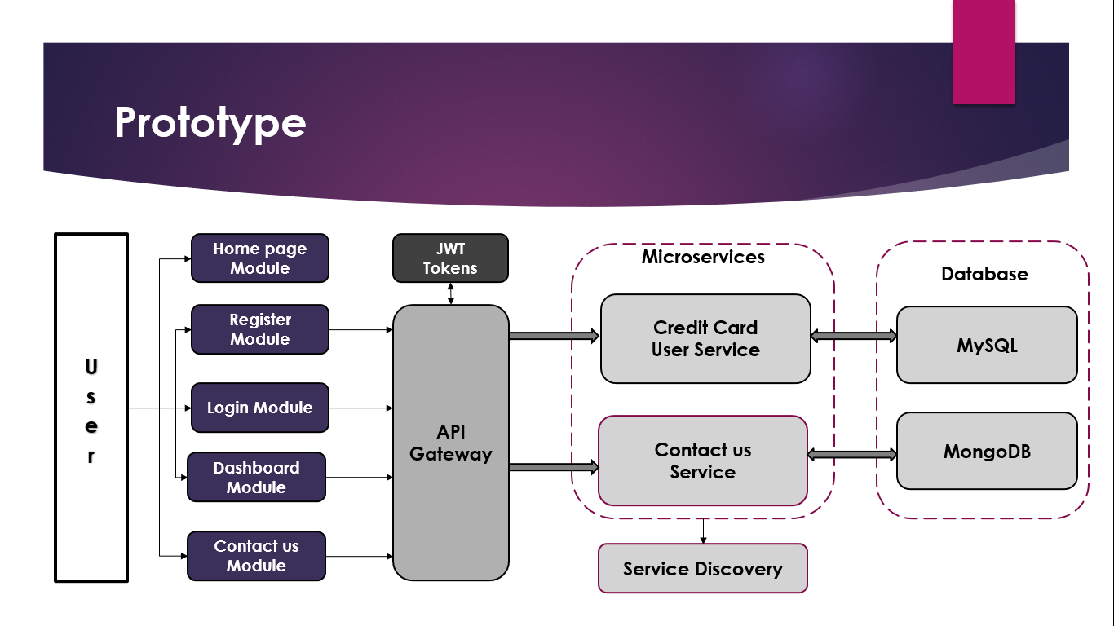

**Entity Relationship Diagram (ER):-**

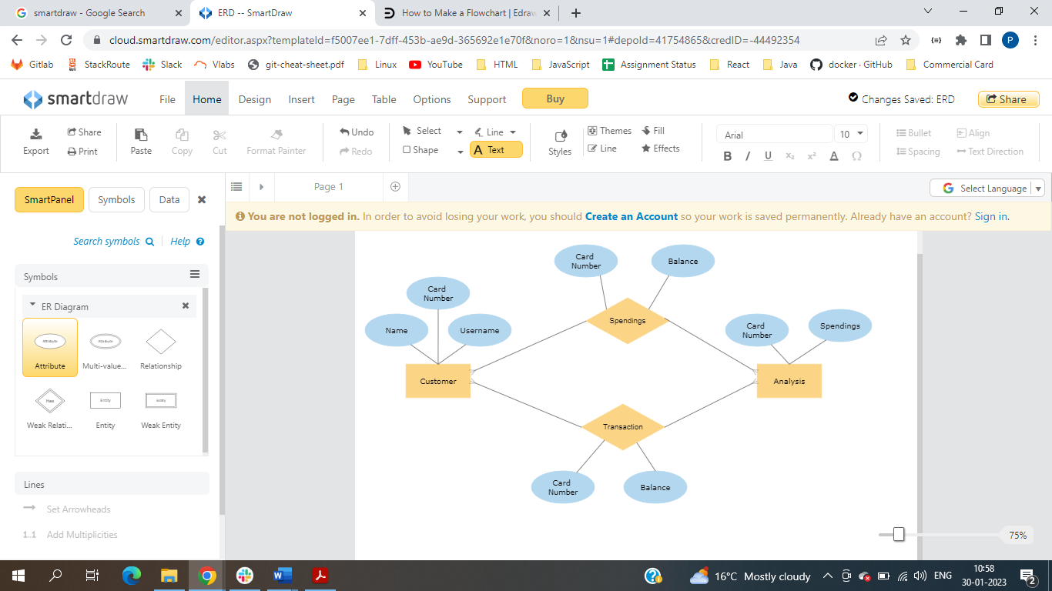

**Database Table Diagram:-**

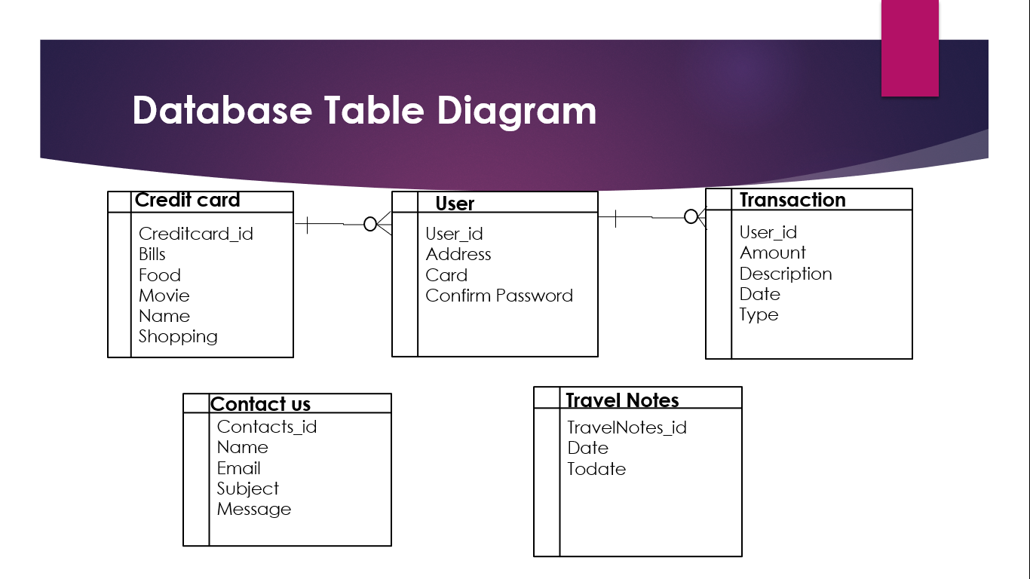

1. **Conclusion:**

The international travel card usage analysis dashboard will provide consumers with a convenient and user-friendly way to view their spend on the travel card and perform search easily. It will be accessible from any device or computer with internet access.

The requirements described in this document will be used to guide the development of the dashboard, and testing will be performed to ensure that it meets these requirements.